Title: The current account and the Balance of Payments
Subject: Macro 1

1. The Current Account  A. Definitions  B. Interpretation  2. Balance of payments  A. Current Account  B. Capital Account  C. Financial Accoun  a. Official Reserve Assets  b. All other assets  c. Statistical discrepancy  D. BoP Accounting  E. Overall Balance  F. Valuation Effects  APPENDIX  Is CA good or bad?  Us CA history | a. The Current account  CA = EX – IM, Flow variable!, if CA > 0: “Current account surplus”, if CA < 0: “Current account deficit”  b. Net foreign assets / Net International Investment (NII)  NFA = A (on foreigners) - L (to foreigners)  ΔNFA = dA (on foreigners) - dL (to foreigners)= CA  NFA is a stock variable, it’s the sum of all past CA, proof:  NFAt – NFAt-1 = CAt $→$ NFAt = CAt + NFAt-1 $→$ NFAt = CAt + CAt-1 + NFAt-2 $→$ NFAt = $\sum_{i = 0}^{N}{{CA}_{t-i}+ {NFA}_{t-N-1}}$  Note: You cannot compare GOOGLE capitalization vs Ita GDP. GDP is a flow variable, Google cap is a stock variable.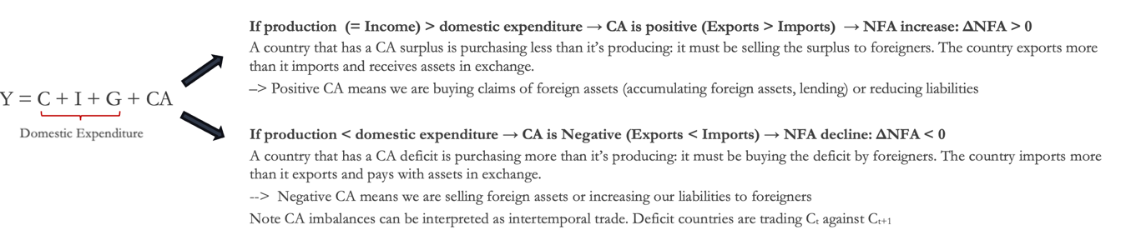  *Us current account history + Is CA deficit necessarily bad? Appendix!  BoP Accounting. Three elements:  A. Current account:  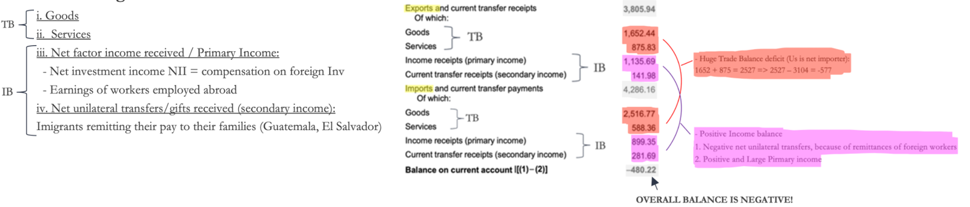  CA is generally determined by the TB, examples  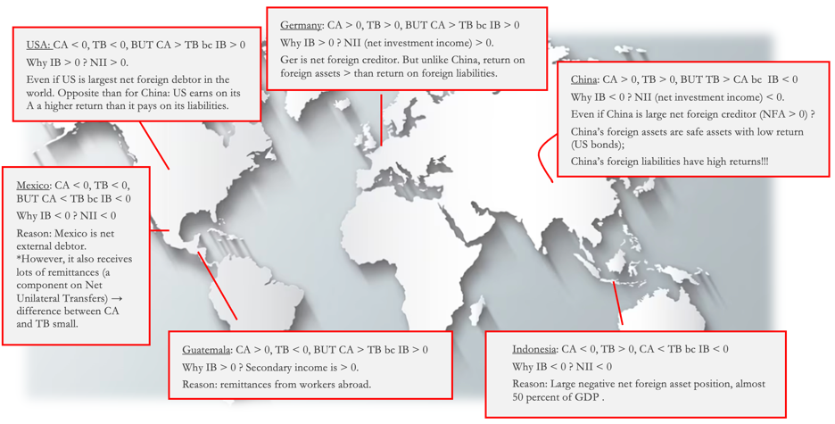  B. Capital account (K): flows of special categories of assets: typically non-market, non-produced, or intangible assets such as debt forgiveness, copyrights, and trademarks.  C. Financial account: accounts for flows of financial assets. Financial account has at least three subcategories  a. Official (international) Reserve Assets (CB FA): foreign assets held by CBs. Basic example is CB buying foreign bonds. But also:  Nissan is paid by Us auto dealer 20,000$. Nissan does not want to hold dollars. BoJ gives Nissan the equivalent in Yen and takes the 20,000$ => The Bank of Japan’s international reserves rise by $20,000  Since Nissan has converted its dollars woth the Boj the FA deficit is CB FA, if Nissan had not converted it is non CB FA.  Why we need Official reserves? CBs often buy or sell international reserves in private asset markets to stabilize exchanges (‘official foreign exchange interventions’) = war chest  Net CB financial flows:  Us Official Reserves – Foreign Offivial Reserve claims on the Us:  $4.66 billion - $61.63 billion=-$56.97 billion in 2019 (note: signs are as in version (2)).  Problem: Suppose the Bank of Japan instead of holding the $20,000 decides to transfer it to Barclays Bank in London.  The end result is that the U.S. incurs an extra $20,000 in liabilities to private foreigners instead of an official reserve liability.  b. All other assets (NON CENTRAL BANK FA): all other transactions we have seen before  c. Statistical discrepancy  The statistical discrepancy is the account added to or subtracted from the financial account to make it balance with the current account and capital account.  In all but one year between 1980 and 2003, the sum of global current accounts was negative.  Since 2004, the measured global current account has been positive.  Accounting procedures. Point of view of the US:  General rule 1 (think at Exports/Imports):  a transaction involving a good is recorded in the CA; a transaction involving an asset is recorded in the financial account (if the asset is marketable) or in the capital account (if it not marketable or intangible)  General rule 2: If the property of a good or asset moves from a national entity to a foreign entity, this is recorded in the BoP wth a positive sign: in the CA if a good (“exports”), in the FA if an asset. If it moves from a foreign entity to a national entity, it is recorded in the BoP with a negative sign: in the CA if a good (“imports”), in the FA if an asset.  General rule 3: Double-entry keeping principle: each transaction must be recorded in the BoP twice, once with a plus sign (credit) and once with a minus sign (debit).  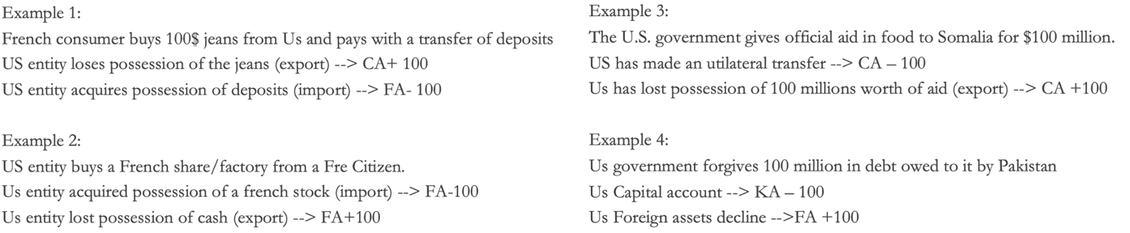  Balance of payment overall balance  Current account + capital account + financial account = 0  => Ignoring KA for simplicity: CA = - FA, but since CA = dNFA –> dNFA = - FA  This is because (counterintuitive) FA is defined as: sales of A to foreignes (Exports = credits) – Acquisition of assets from foreigners (Imports = debits) => If you sell assets FA increases But NFA clearly decreases.  For simplicity, we can write by comvention: FA = debits – credits, s.t. CA + KA = FA  Examples of the FA = dFA relationship:  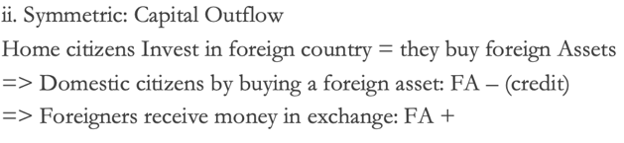  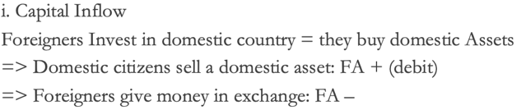  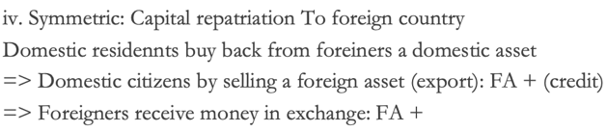  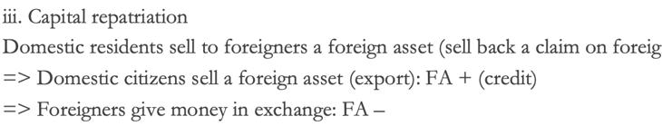  *Debit: they have a claim on us  Key: ‘Trade-related’ capital outflows affect NFA (does not have a double entry on FA) while ‘purely financial’ capital outflows do not (no CA ocunterpart)! Sale of domestic asset to foreign in exchange dor money: sell home stock to foreign (FA + for home, FA – as foreign pays with deposits => dNFA = 0, btw recall CA = dNFA)  We have seen that ΔNFA = CA = dA - dL  But NFA position changes also because:  1) the value of the foreign assets and liabilities denominated in foreign currency changes (ex. fall in Japanese stock mkt)  2) exchange rate changes (e.g., if the dollar appreciates, the value in dollars of Japanese stocks held by U.S. residents declines)  Ex. A 10% depreciation of the dollar would leave U.S. liabilities (measured in dollars) unchanged but would increase U.S. assets (measured in dollars) by 10 * 0.7 (70% of assets are denominated in ofreign currency) * 1.37 (foreign assets % of GDP) =9.6 % of GDP  This number is 4.3 times the U.S. current account deficit of 2019!  No If:  - They had huge I, hence negative CA, but it was good bc I created huge growth = no problem to repay debt in following years (Asian tigers)  Yes If:  - Debt is denominated in foreign currency (a prob that obv Us does not have), hence a huge deficit could become unbearable if the national currency depreciates (Arg)  - Debt was not used efficiently in increasing growth opportunities. Moroever, if you need to reduce the CA deficit you will have to reduce domestic consumption (C + I + G) = recession (Arg)  Cyclical Vs structural fluctuations:  - Cyclical fluctuation: During recessions CA improves… while when you have a big boom in the economy ppl invest a lot, consume a lot, import a lot, CA is negative.  - Structural fluctuation: CA is negative bc the country is not competitive and does not produce the goods the world wants.  Us History  In 70s CA around 0 but NFA increased --> rivaluation of foreign assets  Late 80s: NIIP turns negative  Now: NFA US is negative 80% of current GDP (-17.5 tn, huge!)  The United States has the most negative NFA position in the world (Assets have grown, but liablities have grown even faster), and therefore it is the world’s largest net debtor nation because of the accumulation of CA deficits since the 80s.

